1. BUSINESS DESCRIPTION

1.1 Business Background
Social Media Database is designed to support the core functionality of a social networking platform.
It allows users to register, create profiles, share posts and media, communicate via messages, follow others, use hashtags, and receive notifications.
The system aims to store all necessary user activities while maintaining data integrity and efficient access.

1.2 Problems. Current Situation
Without a centralized database, user-generated data (posts, comments, likes, etc.) become fragmented and hard to manage.
Typical issues include:
- Redundant data about users and posts.
- Difficulty in linking media, hashtags, and user interactions.
- Low performance when retrieving large amounts of content.
- Complications in tracking user relationships and notifications.

1.3 Benefits of Implementing a Database (Project Vision)
The designed database will:
- Store structured information about users, posts, and interactions.
- Allow easy retrieval and filtering of content.
- Support scalability for millions of records.
- Ensure referential integrity and normalization up to the 3rd Normal Form (3NF).
- Support analytical features in the future (trending hashtags, user activity).

2. MODEL DESCRIPTION

2.1 Definitions & Acronyms
Acronym | Meaning
PK | Primary Key
FK | Foreign Key
1:N | One-to-Many relationship
M:N | Many-to-Many relationship
ENUM | Enumerated data type
ERD | Entity-Relationship Diagram

2.2 Logical Scheme
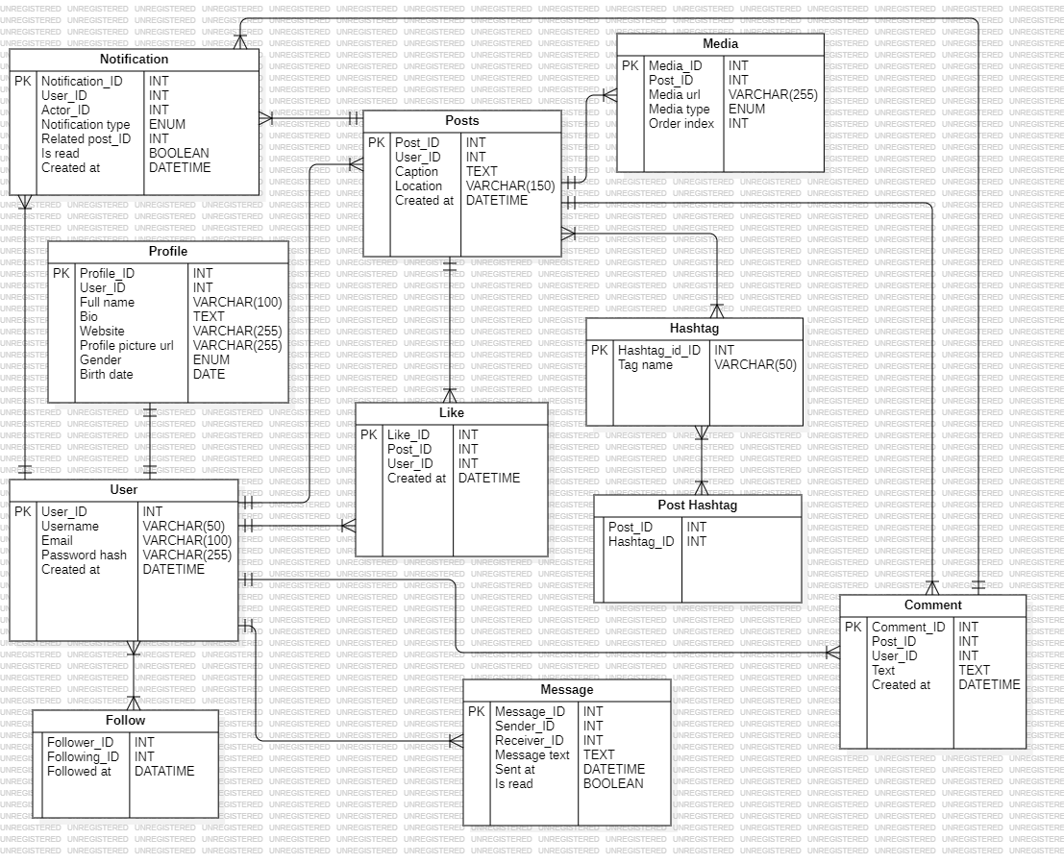

2.3 Objects
Below is a detailed table-by-table breakdown of entities and their fields.

Table: User
Field Name | Description | Data Type
User_ID (PK) | Unique user identifier | INT
Username | Unique username | VARCHAR(50)
Email | User’s email | VARCHAR(100)
Password_hash | Encrypted password | VARCHAR(255)
Created_at | Account creation date | DATETIME

Table: Profile
Field Name | Description | Data Type
Profile_ID (PK) | Unique profile identifier | INT
User_ID (FK) | Link to User | INT
Full_name | Full name | VARCHAR(100)
Bio | User biography | TEXT
Website | Personal website | VARCHAR(255)
Profile_picture_url | Link to profile image | VARCHAR(255)
Gender | User gender | ENUM('male','female','other')
Birth_date | User’s birth date | DATE

Table: Posts
Field Name | Description | Data Type
Post_ID (PK) | Unique post ID | INT
User_ID (FK) | Author of post | INT
Caption | Post text or caption | TEXT
Location | Optional location name | VARCHAR(150)
Created_at | Date and time of creation | DATETIME

Table: Comment
Field Name | Description | Data Type
Comment_ID (PK) | Unique comment ID | INT
Post_ID (FK) | Related post | INT
User_ID (FK) | Author of comment | INT
Text | Comment text | TEXT
Created_at | Date and time | DATETIME

Table: Like
Field Name | Description | Data Type
Like_ID (PK) | Like record ID | INT
Post_ID (FK) | Liked post | INT
User_ID (FK) | User who liked | INT
Created_at | Time of like | DATETIME
(This table resolves the M:N relationship between User and Posts.)

Table: Follow
Field Name | Description | Data Type
Follower_ID (FK) | The user who follows | INT
Following_ID (FK) | The user being followed | INT
Followed_at | Date of follow | DATETIME
(Self-referential M:N relationship within the User table.)

Table: Message
Field Name | Description | Data Type
Message_ID (PK) | Unique message ID | INT
Sender_ID (FK) | Message sender (User) | INT
Receiver_ID (FK) | Message receiver (User) | INT
Message_text | Content of message | TEXT
Sent_at | Time sent | DATETIME
Is_read | Message read status | BOOLEAN

Table: Notification
Field Name | Description | Data Type
Notification_ID (PK) | Notification ID | INT
User_ID (FK) | Receiver of notification | INT
Actor_ID (FK) | Triggering user | INT
Notification_type | Type (like, comment, follow) | ENUM
Related_post_ID | Reference to post (optional) | INT
Is_read | Read status | BOOLEAN
Created_at | Time created | DATETIME

Table: Media
Field Name | Description | Data Type
Media_ID (PK) | Unique media ID | INT
Post_ID (FK) | Related post | INT
Media_url | File path or URL | VARCHAR(255)
Media_type | ENUM('image','video') | ENUM
Order_index | Display order | INT

Table: Hashtag
Field Name | Description | Data Type
Hashtag_ID (PK) | Unique hashtag ID | INT
Tag_name | Hashtag text | VARCHAR(50)

Table: Post_Hashtag
Field Name | Description | Data Type
Post_ID (FK) | Related post | INT
Hashtag_ID (FK) | Related hashtag | INT
(This table resolves the M:N relationship between Posts and Hashtag.)

Comments on Relationships
- User ↔ Profile: 1:1
- User ↔ Posts: 1:N
- User ↔ Comment: 1:N
- User ↔ Message (Sender/Receiver): 1:N (self-relationship)
- User ↔ User (Follow): M:N self-referential
- User ↔ Posts (Like): M:N via Like
- Posts ↔ Media: 1:N
- Posts ↔ Comment: 1:N
- Posts ↔ Hashtag: M:N via Post_Hashtag
- User ↔ Notification: 1:N
- Comment (no recursion) – can be extended later for replies

Example with Data
User_ID |  | Username |  | Email |  | Created_at
1 |  | vita |  | vita@gmail.com |  | 2025-01-01
2 |  | max |  | max@gmail.com |  | 2025-02-03
Post_ID | User_ID |  | Caption |  | Created_at
1 | 1 |  | "My first post!" |  | 2025-01-02
2 | 2 |  | "Nice weather!" |  | 2025-02-03

Like_ID | Post_ID | User_ID | Created_at
1 | 1 | 2 | 2025-01-03
2 | 2 | 1 | 2025-02-04

